Format Science Advances - Research Article
The waggle dance of honeybees communicates locations, not only flight instructions
X. Chen,^{1,*} Z. Wang,^{2,*} B. Wild,^{3,*} F. Becker,⁴ U. Greggers,¹ S. Walter,¹ M. Werner ¹, T. Landgraf,³ , and R. Menzel,^{1,+}
¹ Institute for Biology, Neurobiology, Freie Universität Berlin, Germany; ² CAS Key Laboratory of Tropical Forest Ecology, Xishuangbanna Tropical Botanical Garden, Chinese Academy of Sciences, Kunming 650000, China; ³ Department of Mathematics and Computer Science, Freie Universtität Berlin, Germany, ⁴Institute of Neurobiology and Ethology, Philipps University Marburg, Germany, ⁴Institute of Sericulture and Apiculture, Yunnan Academy of Agriculture Sciences, Mengzi 661101, China

* Shared first authorship, alphabetic order
⁺ menzel@neurobiologie.fu-berlin.de

Abstract 150 words now 149 words

Encoding and decoding processes involved in waggle dance communication were evaluated quantitatively by video recording of dance behavior and by harmonic radar tracking of the recruits` flights. Recruits searched more precisely than expected from distribution of the vector endpoints as encoded in the dancers` waggle runs. This result could be modeled by assuming averaging of 8 – 10 waggle runs. However, the flights of recruits displayed characteristics that indicated additional strategies in relation to their landscape memory. Furthermore, recruits starting at sites other than the hive entrance performed different search flights indicating an expectation about the landscape along the dance indicated feeder. The search patterns at these remote sites were directed towards the dance indicated location, and an elongated ground structure experienced by the dancer acted as a guide for the recruits. We conclude that recruits interpret the vector information from the dancer as a location in their landscape memory.

Introduction
The waggle dance of honeybees is an intriguing example of multisensory convergence, central processing, memory retrieval, symbolic coding and motor coordination (von Frisch, 1955; von Frisch, 1974). A waggling bee moves forward straight ahead on the vertical comb surface in the dark hive while moving its abdomen from side to side at a frequency of 12 – 25 Hz and frequently also vibrating the wings at 140 – 180 Hz when the abdomen reaches its furthest side positions (von Frisch, 1942) Esch. The features of the straight portion of the dance –the ‘waggle-run’ – correlates with the outbound flight towards the indicated location. The speed of the dance rounds, the length and duration of the waggle run and the number of waggles per waggle-run encode the distance, and the direction of the waggle-run relative to gravity codes the direction of the outbound flight relative to the prevailing sun azimuth. It has been difficult to unravel how the bees attending the dance (follower bees also called recruits) decode the information transmitted in the dance and use it for guiding their outbound flights. Tracking of recruits with harmonic radar technology (Riley et al., 2005) proved symbolic information transfer excluding guidance by odors, but the quantitative relations between the encoding and the decoding processes are only partially understood (Preece and Beekman, 2014) (Al Toufailia et al., 2013; Couvillon et al., 2014; Schürch et al., 2013). Since the dance parameters are rather variable it has been frequently asked whether dancers tune the variance of the dance parameters to the particular conditions of communication reporting focused locations with less variance than widely spaced locations (e.g. a new nest site vs distributed feeding sites, (Weidenmuller and Seeley, 1999) (Tanner and Visscher, 2010a). In such a situation dance parameter variance would not reflect unavoidable error (Preece and Beekman 2014) that needs to be eliminated by averaging on the side of the recruit but rather carries information. It was also questioned how recruits could ever find the indicated location given the scatter of the dance parameters if no other cues were used (e.g. odors, (Grüter and Farina, 2009; Wenner et al., 1969) (Reinhard et al., 2004) (Biesmeijer and Seeley, 2005). Furthermore, it was asked at which level of variance dance communication becomes inefficient or obsolete (Okada et al., 2014). These questions arose because the dance parameters could not be directly related to the flight performance of the recruits.
Applying video based analyses of the dances and radar tracking of the recruits´ flights as applied here allow a quantitative comparison of the encoding and decoding processes and overcome the problems connected with odor baited traps (von Frisch, 1967a), (Tanner and Visscher, 2010b). A first step in analyzing the encoding process consisted in determining the distance code and using it together with the directional code in expressing the distribution of endpoints of the vectors in multiple waggle runs. The density distribution of these locations can then be compared with the density distributions of radar fixes during the outbound flights of recruits as a measure of the decoding process. We found less variance in the recruits´ flights than in the dance performance suggesting additional processes involved in decoding the dance message. We then asked whether averaging of multiple waggle runs by the recruit explains more precise searching. A model calculation supports such a conclusion, however particular behavioral patterns indicated some form of reference to the experience of the recruit in the landscape. Bees leaving the hive explore the environment before they start foraging and learn about the sun compass and the landscape features (Capaldi et al., 2000) , (Degen et al., 2015) (Degen et al., 2016)). We, therefore, asked whether recruits apply only the flight instruction from the dancer, the outbound vector to the indicated deeding site, or whether they interpret the vector information in the context of their knowledge about the landscape. In order to address this question the recruits were not only released at the hive entrance but also at other release sites within the explored area around the hive. The release sites differed more or less from the area around the hive, and the search flights differed more at sites which were less similar to the hive area indicating some form of expectation about the landscape features on the way towards the dance indicated location. Furthermore, the recruits searched towards the direction of the dance indicated location, and a highly salient landscape feature experienced by the dancer, an elongated ground structure, acted as a guide for the recruits. Thus the recruits` search flights indicated a strategy beyond a simple application of the dance communicated outbound flight vector and appear to relate the dance information to their landscape memory.

Results

Recruits decode the dance vector information more precisely than it is encoded
Encoding: The waggle dance consists of multiple rounds each divided into the straight waggle run and the curved return run. The indicated distance correlates with the number of waggles, the length of the run and its duration, and the direction of the waggle run relative to gravity on the vertical comb codes the direction of the outbound flight relative to the sun azimuth at the particular time of the day (von Frisch, 1967a). We used the length of the waggle run as a measure of distance and determined the distance function for two colonies used in our experiments (Fig. 1 A). The variance of the distance measure is relatively large although the queens of the two colonies used were genetically closely related and the ground structure was rather similar for the different landscape regions of training. The locations of the two colonies (RH or KH, see Fig. S1) and the direction of training differed (towards east from RH, and towards west for KH). The distance function (Fig.1 A) rose in a nonlinear way for the first 500 m and continued to rise linearly for longer distances.
The distance and direction measures of each waggle run indicated an endpoint of the outbound flight vector. The distribution of the corresponding endpoints averaged for three or 8 waggle runs is shown in Fig. 1 B and C as a heat map using the function given in Fig. 1 A and taking into account the sun azimuth/time function for the study location. The variance of distance measures was larger than that for the directional measure. The error of distance coding (standard deviation/distance in m) and of directional coding (standard deviation in °) was independent of distance leading to the increase of vector endpoints distribution. It thus appeared that the encoding process was rather imprecise particularly in the distance measure. There was also an offset of the center of mass of the dance indicated vector endpoints from the dance indicated location at two distances (905 m, 2214 m) possibly because the step wise training may have led to dances that still reflected prior training sites.

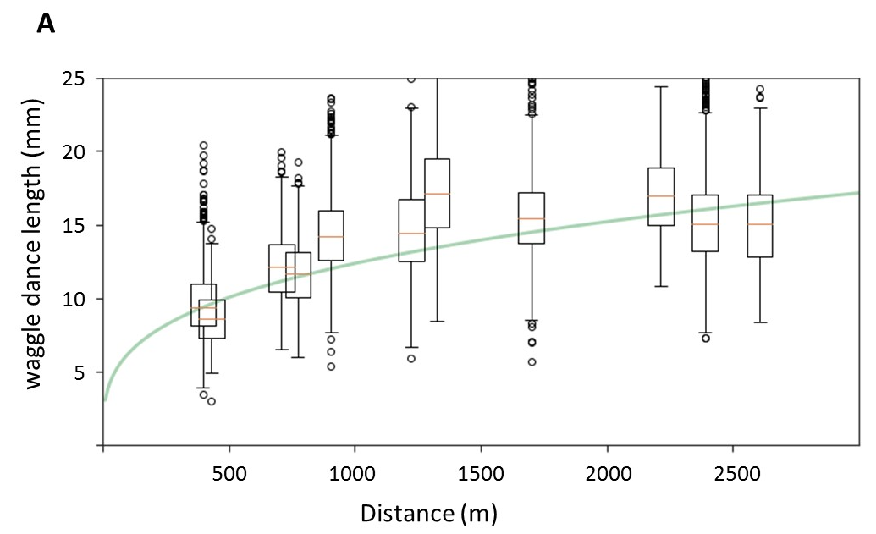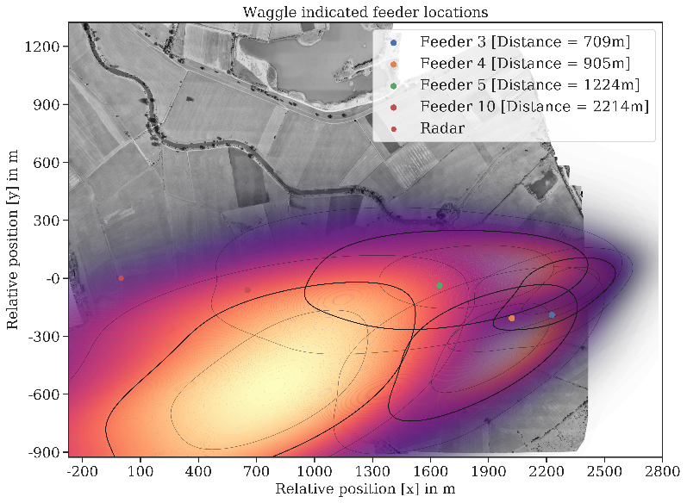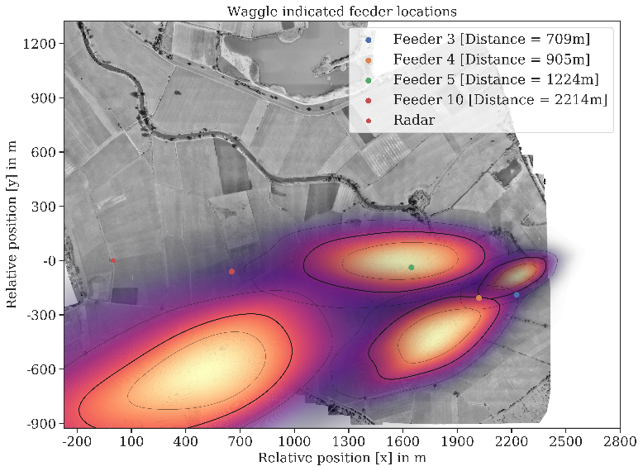

Heat maps will be exchanged
Fig. 1 Encoding of the dance message. A: Correlation between the distance measure (length of the waggle run) and the distance to the indicated feeder. Results from two stepwise training experiment either from hive R/H to the E (2016) or from hive KH to the W (2017) (see Fig. S1). The function gives Steven´s power law fit. Insert here number of dancing bees N and number of waggle runs. B and C: Heat maps of the distributions of dance encoded vector endpoints for 4 (training 2017) after averaging three waggle runs (B) or 8 waggle runs (C). The corresponding training locations (1 – 4) and mean x/y values are connected by lines. Notice the displacements indicated by these lines. The thicker contour lines give the 50% data distributions. Distances of the training locations shown here were: 1: 709 m, 2:905 m, 3: 1224 m, 4: 2214 m.

Decoding: We tracked the outbound flights of recruits with harmonic radar in order to compare the variance of the recruits´ flights with the variance of the dance vector endpoints. Recruits performed first a straight flight after departing from the hive entrance (vector flight) and then a searched before returning to the hive (Fig. 2 A). The transitions from the vector to the search flights and from the search flight to the homing flights were identified by a sudden (from 1 radar fix to the next) turn of > 60° (Methods). Homing flights were not considered further here because all recruits returned successfully home along direct flights at the end of the search. We recorded only the initial part of the vector flights for the two feeding sites F4 and F5 because the range of the radar did not exceed 1.4 km. F6 recruits from hive HK (Fig. S1, 2352 m from the radar) were recorded during their search closer than 1.4 km to the radar. The radar fixes of the search flights for F2, F3 and F6 were used to calculate density maps (Fig. 2 B, C) in order to compare the search flights of recruits with the distribution of dance vector endpoints.
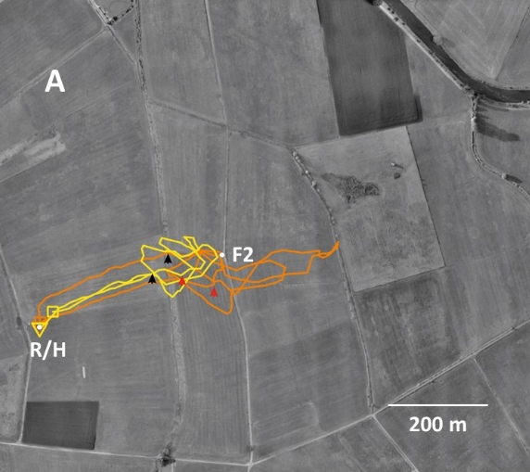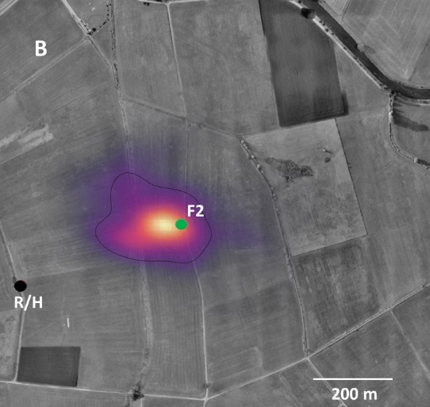
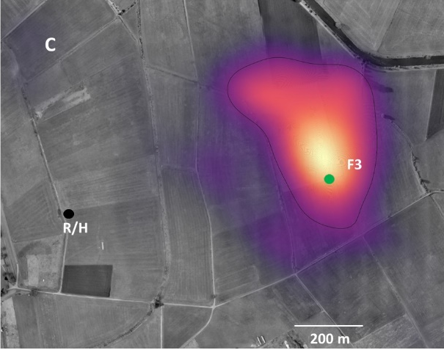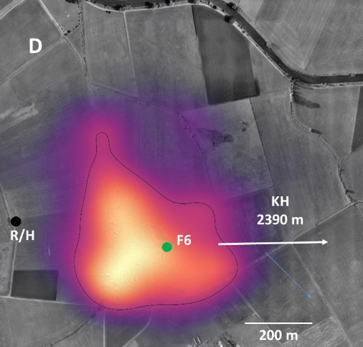
Fig 2 Flights trajectories and density distributions of radar fixes of recruits that had followed dances for feeders F2 and F6. A: Two representative examples of flight trajectories. The black arrows marks the transition from the vector flight to the search, and the red arrows the transition from search to homing. B: Density map of the radar fixes of F2 recruits during their search flights (number of recruits N=50, number of fixes n=2342). C: Similar density map for recruits that followed dances for F3, (number of recruits N=19, number of fixes n=1346). D: Similar density map for recruits that followed dances for F6, (number of recruits N=39, number of fixes n=4482)

Multiple factors may contribute to the precision of searching. Recruits might have followed different numbers of dance rounds performed by the same or different dancers, a parameter which we could not determine. The motivation of dancing and dance following may have differed because of the overall need of the colony for sugar supply. Preparing recruits for radar tracking requires several manipulations (constraining the departing recruit at the hive entrance in a marking device, pushing it with a stopper against a mash, gluing the transponder on their number tag, letting them wait in a dark box for several minutes). A combination of these parameters may have led to more or less motivated and informed recruits. The data of F2 and F3 recruits allowed us to address this question.
All recruits for F2 (N=81) departed from the hive, 9 were lost within 120 m from the hive possibly because the transponder may have detached, 8 by-passed the F2 region for an unknown destination outside the range of the radar leaving 64 for further analysis. The mean length of vector flight (ACL, accumulated length, see Fig. S2 for the definitions of the measures extracted from the flight trajectories) was 342±140 sd with a mean direction of 64±13° sd (the geographic distance between hive and F2 was 397 m, and the direction 71°). The corresponding numbers of F3 were: 22 recruits started at the hive, 3 by-passed F3 leaving 19 recruits for analyses. The mean length of the vector flight was 697± 111 m and the mean direction 77°±11 (geographic distance 773 m, direction: 82°). In order to address the question whether higher motivated or less disturbed recruits performed more precise vector and search flights we analyzed separately recruits with short and long vector flights arguing that more motivated recruits would perform longer vector flights. For F2 recruits we pooled the flight trajectories of animals performing vector flights shorter than 250 m (short vector, N=18) and those with vector flights > 300 m (long vector, N=27) arguing that longer vector flights might reflect more motivated recruits. The most frequent group with vector length of 250 -300 m was left out (N=19). No statistically significant differences were found between these two groups for the average vector directions (short vector group: 57°± 16° sd, long vector group 65°± 13° sd, Watson U² test) and for the speed of the vector flight (short vector group: 8.0±2.2 m/s sd; long vector group: 7.5±1.8 m/s sd, Wilcoxon rank sum test). However, the average of the Euclidian distances of all search flight fixes to F2 differed significantly between the two groups (short vector group: 160±72 m sd, number of animals: N=18, number of fixes n=734; long vector group 127±81 sd N=27, n=779; p< 0.01, Wilcoxon rank sum test). A similar analysis was performed for recruits to F3 (geographic distance 773 m). The group with short vector flights (< 650 m, average: 562±94 sd m) and the group with long vector flights (> 700 m, average: 722±54 sd m) were also not significantly different with respect to their vector directions (short vector group 80°±14° sd, long vector group 78°±8, Watson-William F-test) and with respect to the vector flight speed (short vector group: 5.6±1.3 m/s, long vector group 4.9±1.4 m/s, Wilcoxon rank sum test). Again the Euclidean distances for search part differed significantly between those that performed short and long vector flights (short: 271±117 m, N=6, n=401; long vector: 162±102 m, N=12, n=589; p<0.01, Wilcoxon rank sum test). Thus recruits with higher motivation as indicated by longer vector flights were more precise in spotting the dance communicated feeder. This conclusion is supported by the positive correlation between the deviations of the vector flight directions from the ideal direction (Δα) and the sum of the Euclidian distances to the respective feeder (correlation coefficient F2: 0.61, F3: 0.39, Spearman correlation, see Fig. S3) and the anti-correlation between the length of the vector flight and the average of the Euclidean distances of search flight fixes (F2: -0.36; F3: - 0.56, Pearson´s product-moment correlation).
The success rate of the recruits as measured by arriving at the dance indicated feeder and feeding there was very low. Only 3 of a total of 402 recruits to all feeders (F1, F2, F3, F4, F5, F6 released either at the hive entrance or other release sites) landed, and this feeder was F2 after the recruits started at hive RH. This result is not surprising given that fact that we did not use any odors at the feeder, and the feeder did not resemble any natural cues (a plastic container on a small table without any additional visual marks).

Comparison between encoding and decoding: The comparison between the density distributions of dance vector endpoints and search flight fixes showed that the latter distributions were significantly narrower for both the range parameter (distance) and the bearing parameter (angle) (Fig 3; compare also Fig. 1 B, C with Fig. 2 B,C,D, and Fig. 2 B,C with Fig. 3 B,C). The range parameter increased significantly with distance for both the encoding (p xxx) and the decoding (P xxx) process but more strongly for encoding. The bearing parameter as measured by the angle from the hive decreased significantly for the decoding process (p xxx) what happened with the x/y values for bearing?
Fig 3 B bearing as expressed in x/y values will be inserted here
There will be two more figures (Fig. C and D) with heat maps of encoding for F2, F3,
Fig. 3 Comparison of the encoding and decoding process. Three corresponding feeders (F2, F3 and F6) were selected for the distribution of dance indicated vector endpoints and distributions of the recruits` search flight fixes. Both range and bearing were expressed in the x/y values of the map. Notice the log scale of the ordinate. B: Comparison of the bearing parameter as expressed in x/y values. See Fig. S4 for an expression of bearing in degree as seen from the respective hive. C and D: Density distributions of the vector endpoints for dances for feeder 2 (C) and feeder F3 (D). Statistics here

The distribution of endpoints of dance communicated vectors for F2 and F6 (also F3?) as well as the distribution of search flight fixes for F2 , F3 and F6 recruits indicated a constant angular scatter for these three distances stimmt der zweite Teil des Satzes).
More focused searching could result from averaging across multiple waggle runs. We ran a model calculation in which we simulated the improvement for different numbers of averaged waggle runs and found the best agreement for 5 – 10 averaged waggle runs (Fig. S 4). We found a close fit between the spread of the encoding and decoding process with averaging of 8 waggle runs. Did we do this also separately for range and bearing?

was
Deviations from dance information: Most likely recruits have foraging experience before they followed a dancer to one of our feeding sites. The dance information is known to reactivate their memory for a former food site (Biesmeijer and Seeley, 2005), (Menzel et al., 2011). We found several flights that resembled such a reminder function of dance following. For example, a F3 recruits flew first towards north to an unknown natural food source, then turned towards F3 before homing Fig. 5 A, red line), and another F3 recruit flew first to F3, and turned towards the same norther area after short searching at F3 (Fig. 5 A, orange line). This natural food site may well have been a patch of purple Loosestrife (Lythrum spec.) which bloomed close to an irrigation channel in a grassland that was regularly cut by farmers and were we observed honeybees and bumble bees. Recruits may also by-pass the dance indicated feeder and head towards an unknown natural food site outside the radar range (Fig. 5 A, B). These flights illustrate the capacity of recruits to perform shortcuts between a dance indicated location and a supposedly learned feeding site.

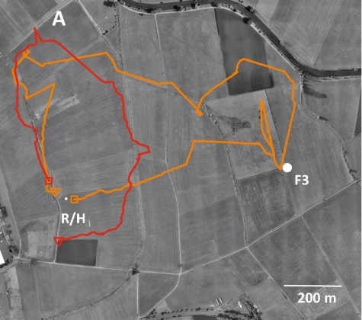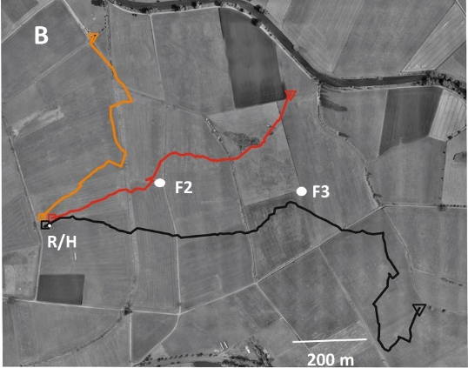

Fig. 5 Redirected flights of recruits. A: Three recruits that had followed a dance for F3. Two of them (red and orange) visited a natural feeding site N of the radar hive (R/H) where they might have foraged at Loosestrife (Lythrum spec.). Notice that animal with the red trajectory flew first to this natural food site and the animal with the orange trajectory first towards F3 and from there to this site. B: Two recruits that had followed a dance for F2 and either redirected their flight to a norther unknown destination outside the radar range (orange) or by-passed F2 and continued flying NE leaving the radar range (red). The square marks the beginning of the trajectory and the triangle the end. Two more examples of redirected flights are shown in Fig. Sxx.

Recruits expect landscape structures
If recruits learn from the dancer only the vector information in form of a flight instruction and are ignorant about the landscape experienced during their outbound flight they should perform similarly when released at a release site other than the hive entrance. This is not the case. We evaluated multiple behavioral parameters of F2 recruits´ vector and search flights and found differences that depended on the location of the release site. Fig. 6 shows the release sites and a table with the behaviors analyzed sorted according to the rank order of 7 behavioral measures of vector flights in relation to the respective measures for recruits released at the hive (see also supplement table S1 for the respective values and the statistics). Vector length was longer after release at R1 and R2, and shorter after R5, R6 and R8 release. The straightness was lower after departure from all release sites as compared to release at the hive entrance. The sum of Euclidian distances of the vector endpoints to F2 was larger after departure from all release sites. Interestingly, the angle to N of the vector flights was significantly larger after release from R2, thus it was tilted towards F2. The sum of rank orders as a measure of significant difference to the respective behavior after release at the hive followed this sequence: HR<R1<R2<R5<R6<R8. Thus least differences were found for R1 and R2 (3 each significant differences out of 7), the release sites north and south of the hive located at path 1 as the hive. Largest differences were found for R6 and R8 (6 significant differences respectively out of 7), released sites further NE than F2. Intermediate differences were found for release site R5 (6 significant differences out of 7), a release site also further to the E but closer to F2.Thus the recruits appeared to recognize that they started at an unexpected location, and behaved differently depending on some measure of difference to the conditions at the hive entrance.
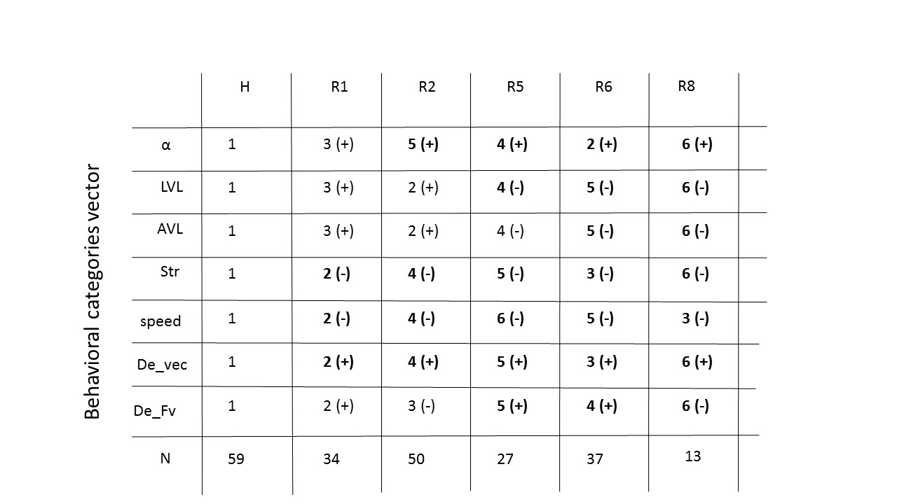
Fig. 6 Behavioral effects of releasing recruits not at the hive entrance but at different release sites. A: Release sites for F2 recruits at the hive (H) or at release sites R1, R2, R5, R6 and R8. B: rank orders (1 – 6) of 7 behavioral parameters of recruits´ vector flights sorted according to the respective release site. Rank order 1 corresponds to hive release, rank order 6 to the lowest rank. The behavioral categories are: α: angle to N of the linearly approximated vector flight; LVL: linearly approximated length of vector; AVL: accurate length of vector; Str.: straightness of vector flight: speed: flight speed of the vector flight; speed: flight speed during the vector flight; De_vec.: average of Euclidian distances between the real feeder F2 (=F2r) and the endpoints of the vector flights; De_Fv.: average of Euclidian distances between the virtual feeder F2 (F2v) and the endpoints of the vector flights. F2v is the location at the endpoint of the ideal vector between hive and F2 when the vector originated at the respective release site. Notice that F2r and F2v are identical for hive released F2 recruits. The respective behavioral values for hive released (H) recruits were set to 1. Deviation from that value can be + or -. In case of the angular deviation + α is anticlockwise. Rank order 2 is closest to the respective value, 6 is furthest away. Bold numbers indicate significant differences between the respective behavioral measures at that release site to the corresponding behavioral measure for recruits released at the hive. Table S1 gives the respective values for the behavioral measures and the statistics.

Our further analyses focused on the search flights of F2 recruits released at R1, R2, R5, R6 and R8 asking whether the search patterns indicated any tendency to deviate from the vector information and aim towards the location of F2. Recruits returned frequently to the release sites during their searches after they had terminated their vector flights, a behavior we did not see after hive release. First we compared the vector flights of release sites R1 and R2, two sites that were located at the same salient elongated ground structure, a gravel road stretching S-N (P1), as the hive but were located S (R1) or N (R2) from the hive. Analyzing the respective angular deviations from the ideal vector to F2v, the virtual F2 feeder (Δα) we found significant differences (Δα_{R1}= 2.7±20.1; Δα_{R2} = -11.9±24.6; p=0.001, Wilcoxon rank sum test) with directions tilted to N at R1 and to S at R2. The vector flights after release at R1 and R2 lead to search flights that were tilted towards F2r (Fig. 7 A, B). The mean angle of the line between each respective search fixes and release sites (angle β) was significantly different (Watson- U² test, p < 0.01, β_{R1} = 64.4 ± 19.2, n= 1469, N=30; β_{R2} = 84.9 ± 39.6, n= 1480, N=40). Significant differences were found also between β_{R1} and β_{HR} (Watson- U² test, p < 0.01, β_{R1} = 64.4 ± 19.2, n= 1469, N=30; β_{HR} = 64.4 ± 15.2, n= 2343, N=50) as well as between β_{R2} and β_{HR} (Watson- U² test, p< 0.01, β_{R2} = 84.9 ± 39.2, n= 1480, N=40; β_{HR} = 64.4 ± 15.2, n= 2343, N=50). The average of Euclidian distances (De) between search flight fixes and F2r were significantly smaller than to F2v after release at R1 and R2 (R1 release: Wilcoxon rank sum test: p<0.01. De to F2r: 250.0±111.6 (SD); De to Fv: 163.5±76.6(SD), N=30, n=1495; R2 release: p<0.05. De to Fr: 268.6±111.6 (SD); De to Fv: 209.3±118.4(SD), N=40, n=1637) indicating that the recruits searched more around F2r than around F2v after departing from R1 or R2.

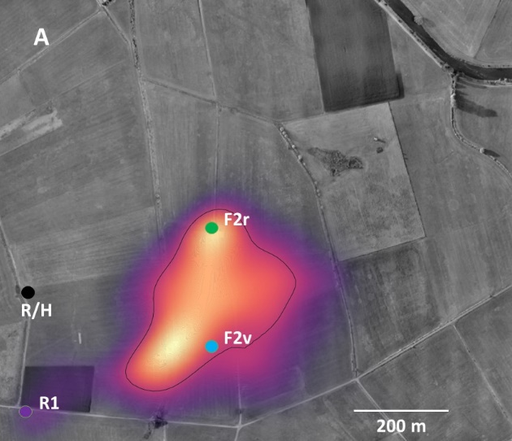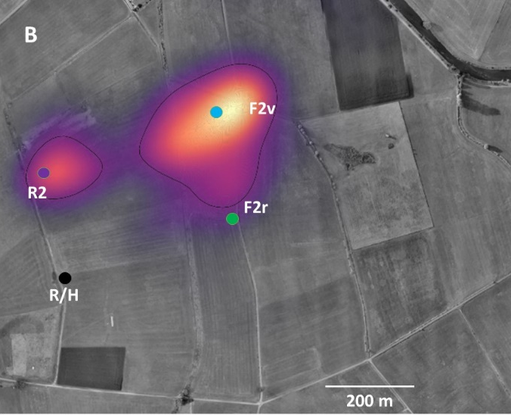
Fig. 7 Density distribution of search flight fixes of F2 recruits that were released either at R1 (A) or at and R2 (B). R/H: Hive in the radar cabin, F2r: the feeder which the dancer indicated, F2v: the corresponding virtual feeder at the same distance and direction as seen from the respective release site, R1, R2: release sites. A: Number of animals: N=30, number of search flight fixes: n=1495; B: N=40, number of search flight fixes: n=1637.

Release sites R5, R6 and R8 were located further in the E at distances from the hive slightly larger than the distance between hive and F2r making the angle between the respective release site to F2r and F2v more different. The vector flights were shorter at these release sites, and their directions were significantly different from those at the hive (Table S1). Fig. 8 A – F show representative examples of search flight trajectories and density distributions of all search flight fixes for the releases of F2 recruits at R5, R6 and R8. Notice that R5 and R8 were about equally distant from F2r in the S and N respectively, and R6 was very close to F2r. The distributions of the directions β between release sites R5, R6 or R8 and the respective search fixes were analyzed using model-based approaches of circular data (Fitak and Johnsen, 2017) (see Fig. Sxx). The Akaike Information Criterion (AIC, (Akaike, 1973) as the sum of the model fit was used to select the model with the smallest AIC as the best model and as a measure to determine bimodality. The best bimodal model for all three release sites was M5B with p<0.001 indicating bimodal distributions. The lowest p value was found for R5, somewhat higher for R6 and higher for R8 indicating significant bimodal distributions with directions towards F2v and F2r. The two directions in each of the three release sites point towards F2v and F2r respectively. Since the center of search was shifted to N for unknown reasons in R8 we also calculated the distribution of β originating in this center and found also a bimodal distribution with directions pointing S and SW close to the direction towards F2r. There was no indication anymore for a direction towards F2v possibly indicating that the shift from R8 to the center of search includes a component of F2v directed flights although displaced N (Fig. 8F and Fig. Sxx). The S and SW pointing directions include search towards F2r and possibly also a component of searching towards the hive. However the limited data and the small angular difference between these two directions do not allow further analyses.

Fig. 8 Representative search flight trajectories and density distributions of search flight fixes of F2 recruits released at three different release sites. A: animals F2RDR5r270(2015), r343 (2015), r474 (2015), yellow473 (2015), B: R5 (Number of animals: N=33, number of search flight fixes: n=3312); C: animals F2RDR6_w136 (2015), F2RDR6_y210 (2015), F2RDR6_y342 (2016), F2RDR6_w345 (2016), D: R6 Number of animals: N=34, number of search flight fixes: n=2634; E: R8 animals F2RDR12_145 (2017), F2RDR12_w440 (2017) (Number of animals: N=43, number of search flight fixes: n=1753).
Taken together these results indicate that F2 recruits search not only in the direction of the dance indicated vector (direction towards F2v) but also towards the location of the real feeder F2r.
This goes into the Supplement:
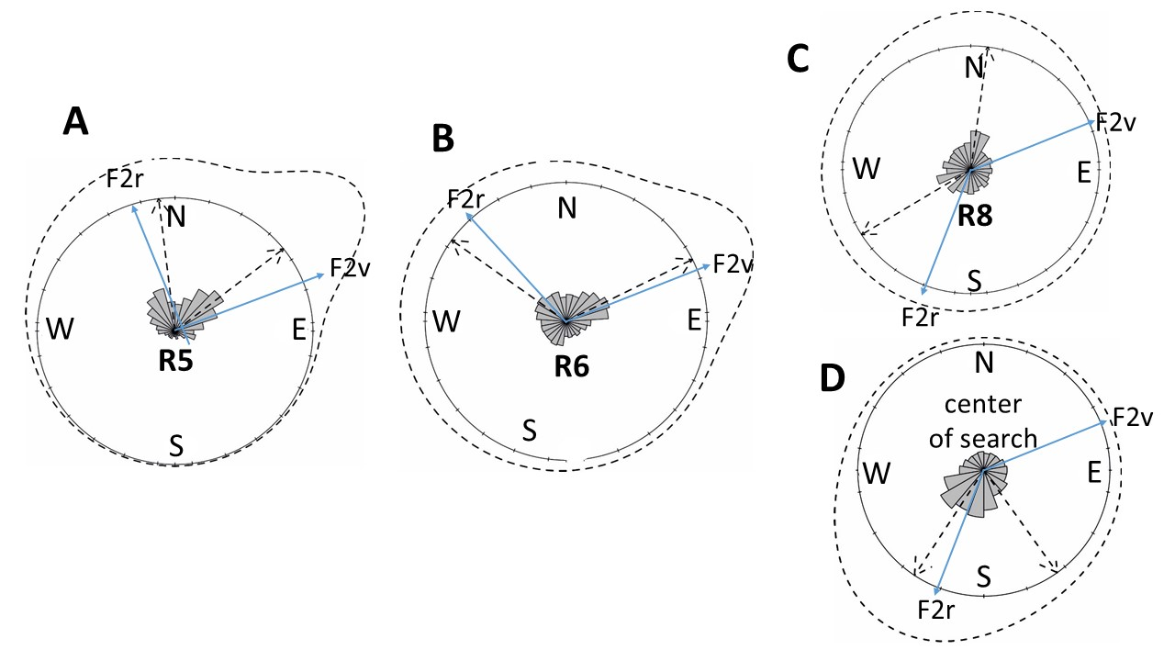
Fig Sxxx Results of the bimodality model calculations for the distribution of β at three different release site (A: R5, B: R6, C: R8). D: The angle β was also calculated with respect to the center of mass after release at R8 because other than in R5 and R6 the densest distribution of search fixes (center of search) was shifted to N by an unknown reason. The blue arrows in each subfigure point to F2r and F2v respectively. Number of animals (N) and search fixes (n): R5: N=33, n=3312. R6: N=34, n=2634. R8: N=43, n=1753. . Should we give the data from the bimodality models?

Next we asked whether recruits developed an expectation about certain landscape features along their flight towards the dance indicated location. These would be the landscape features the dancer experienced during its flights to the feeder. To test this hypothesis we compared the recruits´ flights that had followed dances for F1 and were released at either R3 or R4. The dancers for F1 flew along an approximately S-N stretching gravel road (Fig. 9, P1). F1 recruits released further to the E at R3 faced conditions close to that of their dancers with respect to the direction of a gravel road (P3). P1 and P3 gravel roads had similar appearance and close to similar directions. F1 recruits released at R4, however, flew over even grassland during their vector and search flights. Fig. 9 A and B show representative flight trajectories of the search flights of F1 recruits released at R3 or R4 respectively, and Fig. 9 C gives the corresponding density distributions. The distributions of β were again analyzed with model-based approaches of circular data (Fitak and Johnsen, 2017) (see Fig. Sxx), and the Akaike Information Criterion (AIC, (Akaike, 1973) was applied to select the best model as a measure of uni- or bimodality. β-distributions of search flight fixes were uni-modal both at R3 and at R4 (R3: modified uni-modal M2C p< 0.0001, R4: M2B, p<0.0001 using the 10 models in the the paper cited above. Should we rather use only the 4 models: M1, M2A, M4B and M5B?). Since there was a tendency of R3 released recruits to fly also along P2 (the path west of P3) we ran also a model with β of search flight fixes in the range 200 – 250 m from R3 and did also not find a bimodal distribution. Notice that the directions towards F1v and F1r were rather similar. The frequency of the distances between the respective release and the search flight fixes were significantly different (De_{R3}= 318.4±218.6; De_{R4}=217.3±199.6, p<0.01, Wilcoxon rank sum test). R3 released recruits stretched their search flights along P3 and those at R4 searched more closely around R4. Thus the search flight pattern of F1 recruits was much more elongated in the direction of the dance indicated vector if they flew along a salient ground structure stretching in the same direction as a similar structure experienced by the dancer.
The different search patterns of F1 recruits released at R3 and R4 may result from a tendency to follow innately a salient elongated ground structure. We designed the experiments with F2 recruits in such a way that one of the release sites (R5) acted as a control experiments. F2 appeared from the hive R/H in a direction close to that of a narrow road at R5 stretching SW to NE (see Fig. 8 A, B). The dancer for F2 flew over even grassland and therefore was not exposed to an elongated grand structure along its way. Thus, if the F2 recruits released at R5 would have a tendency in their F2v-directed search to follow such a salient elongated ground structure they should fly along the narrow road, and thus the search flight fixes should scatter around the road. This is not the case. Search flight fixes of F3 release recruits, however, scatter around P3. (Fig. Sxx). This result rules out the possibility that recruits have a tendency to follow an elongated ground structure independent of what their dancer experienced. Taken together, these results indicate a preference for a landscape feature the respective dancer experienced on its flights between hive and feeder.
This goes into the supplement:
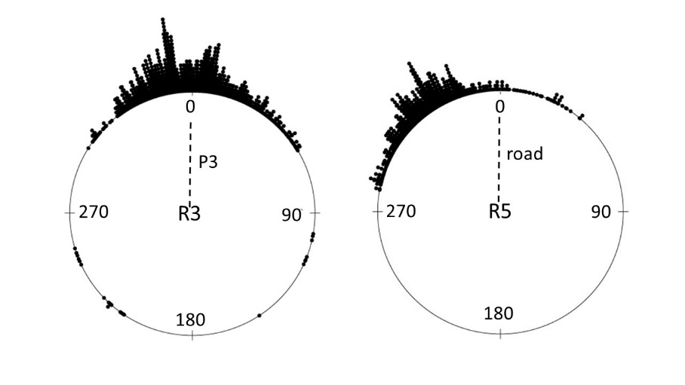
Fig comp R3_R5 structure Comparison of directions β for search fixes further away than 200 m from the respective release sites R3 and R5. The directions were normalized to the direction of the elongated ground structure at R3 (path P3 stretching predominantly S to N) and at R5 (narrow road stretching predominantly SW to NE). The distributions are significantly different (p<0.01 Watson- U² test, R3: n=1636, R5: n=1041). Search fixes of R5 released recruits did not scatter around the elongated ground structure as is the case in R3 released recruits.

Fig. 9 Search flight trajectories and density distributions of search fixes of F1 recruits released at R3 or R4. A: Three representative search flight trajectories of F1 recruits released at R3 (animals ….). B: Density distributions of search fixes of F1 recruits released at R3 (Number of animals: N=27, number of search flight fixes: n=2576). C: Three search flight trajectories of F1 recruits released at R4 (animals …). D: Density distributions of search fixes of F1 recruits released at R4. (Number of animals: N=34, number of search flight fixes: n=4827). Notice that F1 recruits that started at R3 and thus first flew along P3 tended to also partly follow P2 (see Fig. Sxx). R/H: Radar and hive; F1: feeder for F1 dancers; R3 and R4: release sites; F1v: virtual F1; P1 – P4: S-N stretching paths. D: Distributions of distance between the search flight fixes and the release sites R3 or R4 for recruits starting at the respective release site. The distribution of Euclidean distances of search flight fixes from release sites R3 and R4 are significantly different (p< 0.05 Wilcoxon rank sum test). Direction??

Discussion
Encoding and decoding
Symbolic communication systems like the honeybee waggle dance translate the measures in one context (outbound flight vector) into coding signals transmitted to the receivers in another context (wagging movements on the vertical comb in the dark hive). One might assume at the outset that such a complex symbolic encoding/decoding process performed by a very small brain works at its limits of precision both at the sender and receiver side. Discuss here the results of
(Haldane and Spurway, 1954): Information content, distance code log, number of waggles are the distance code (p. 270), one waggle = 75 m. Siehe auch S. 251 – 252 in Hölldobler/Wilson The Superorganism. Thus any scatter inherent to the encoding and decoding processes would be of stochastic nature reflecting that the bee cannot do better (encoding: (Preece and Beekman, 2014). We have applied this assumption in our first analyses of variance of the encoding of the distance and direction codes as has been done in many other studies of the dance performance (Tanner and Visscher, 2010a) (De Marco et al., 2008; Okada et al., 2014). We found that the scatter of the distance code (length of the waggle run) as well as that of the direction code (angle relative to gravity) are constant and independent of distance (in the range of 400 m to 2600 m) with an effective larger scatter in the distance code. The consequence is that the density distribution of corresponding endpoints of the dance indicated vectors are not circular but oval with a longer axes in the range dimension (Fig. 1 B). These findings do not support those by (Esch, 1978) (Beekman et al., 2005) (De Marco et al., 2008) with respect to the distance code and (von Frisch, 1967b), (Towne and Gould, 1988), (Al Toufailia et al., 2013), (De Marco et al., 2008) with respect to the direction code possibly because different measures for the direction code were evaluated and shorter distances were tested.
The receiving animal will gain from averaging across multiple waggle rounds if the signal contains random fluctuations (Frisch and Jander, 1957). Dance following bees usually do not observe just one waggle run. Different numbers of rounds followed were observed (8 rounds by (Judd, 1994), 17 rounds by (Grüter et al., 2008), on average of 2.8 rounds (range 1 – 16) by (Al Toufailia et al., 2013), however neither the dancers nor the followers were individually marked in these studies, and thus it could not be to excluded that a dance follower had attended more than the observed dance. It was also not clear whether the follower started a foraging trip afterwards. The most informative data on dance following come from (Biesmeijer and Seeley, 2005) who found that the number of dances followed and thus were potentially averaged depended on the experience of the follower (whether it was already known to the follower or novel), the food source advertised and on both the season and the time of the day. Overall 2 – 4 dance rounds were followed in their study. In a former study on dance following and foraging trips to either the learned location or the dance communicated location we found that after following on average 8.4 rounds (30° experiment) or 16.4 rounds (60° experiment) the followers preferred to fly to the learned location, and after following on average 20.7 (30° experiment) or 23.3 rounds (60° experiment) they flew towards the dance indicated location (Menzel et al., 2011). It thus appears that the large range of dance following behavior reflects conditions of the communication process that involves evaluation of the information received and the level of experience the follower has with the indicated location. In the case of a novel location for the follower it may also depend on whether the divergence angle between consecutive dance rounds carries information and needs to be evaluated. According to the tuned error hypothesis the divergence angle between directions of the waggle run following a right or left loop of return run is a specific indicator for a feeding site possibly indicating the distribution of multiple food sites (Biesmeijer and Seeley, 2005).
Although averaging might help to reduce noise in the dance communication system it appears that neither the scatter of dance data nor the reception and use of these data by the recruit may solely reflect stochastic fluctuations because the dancer nor the recruit may not be able to do better. This reservation is supported by the finding that both distance and direction codes are expressed more precisely if the dancer indicates the flight vector towards a novel nest site (Weidenmuller and Seeley, 1999). Therefore, errors as they appear to the human observer may not reflect unavoidable impression but carry information, e.g. coding distributed feeding sites vs a localized potential nest site as assumed in the tuned-error hypothesis (Haldane and Spurway, 1954), (Wilson, 1962), (von Frisch, 1967a). It could also be that systematic deviations from the ideal vector are either neglected or corrected by the receiving bee. For example, comparisons between colonies located in different landscapes may be misleading since the bees may have calibrated their odometer differently (Srinivasan, 2010), or may have differing genetic background. Indeed significant differences were found between colonies (Al Toufailia et al., 2013). Systematic deviations with respect to direction are known for the divergence angle of the waggle runs between runs following right turns or left turns (e.g. Weidenmuller and Seeley, 1999), their Fig. 3) which could potentially be corrected by the follower. Also the systematic deviation of the waggle runs´ angle in dependence to the angle to gravity known as residual misdirection von (von Frisch, 1967a) may not be an error. Do we include the calculation of the misdirection? Furthermore, correlated codes for distance (duration of waggle rounds, length and duration of waggle run, number of waggles) and different sensory modalities involved in receiving the waggle run signals (mechanical and electrostatic signals, (Greggers et al., 2013) may reduce the uncertainties in the signals, and indeed additional visual signals lead to less variance than gravity signals alone (Tanner and Visscher, 2010a). Taken together not only averaging but also convergent stimulus modalities and corrections of systematic deviations by the receiving animal may lead to more precise information transfer, and thus to more narrow search areas of the recruits.
A major challenge for von Frisch in proofing the waggle dance interpretation was the demonstration of focused search patterns in recruits, dance followers that left the hive after attending a dance. He and others used odor baited traps to attract recruits to test stations for counting. (von Frisch, 1967a) found more narrow searches as expected from the scatter of the dance parameters (distance: his p.107, direction: his p.157-162). Towne and Gould 1988 (their Fig. 13) estimated more precise directional search for long than for short distances (±5.4° for 700 m, ±30.9° for 100 m), and (Tanner and Visscher, 2008) found bees to search in more narrow directions than expected if they would have used only one waggle run to guide their search (their Fig. 4). The use of odor baited traps has been heavily criticized (Wenner et al., 1969), and even von Frisch acknowledged the problems of this technique (von Frisch, 1967a), (Lindauer, 1971). Radar tracking of recruits demonstrated a highly focused search at the endpoint of the dance indicated vector, but it also documented additional effects caused by highly salient landmarks (Riley et al., 2005). The flight trajectories reported here have a peak of the search fixes very close to the dance indicated goal although the vector flights are rather broadly distributed and also the search flight fixes spread over considerable areas indicating additional parameters influencing the recruits´ flight behavior. Highly motivated recruits as identified by longer vector flights (> 50% of the distance hive-feeder) search more focused. Motivation may depend on the number of waggle rounds followed, a parameter which we could not measure under our experimental conditions. Deviations of the vector flight from the ideal direction to the feeder were compensated for in the initial phase of the search flight. Do we include the figure in the supplement? Thus recruits keep a memory of the dance information throughout their outbound flight.
Total of 402 recruits tested
Only very few recruits (F2: 3 out of 54, none at F3 to F6) landed at the feeder although in the case of F2 25 approaches were recorded in the 17 recruits that came closer than 30 m. This is not surprising given the conditions of our experimental conditions. Although the recruits were experienced foragers the indicated feeder was novel to them and they departed from the hive only once. (Biesmeijer and Seeley, 2005) estimated that the chance to successfully returning from such a novel food source is very low making it necessary to follow additional dances for the same source. Since the areas around the feeders were devoid of natural food sources even a partial confirmation of formerly visited food sources was not possible in our test conditions. Furthermore, the feeders for the dancers lacked odor cues and any visual cues that would be reminiscent of natural visual cues (color, pattern, shape).
Given the lack of close cues at the feeder a searching recruit may have shifted from spotting the dance indicated place to an exploratory motivation collecting additional information about the landscape as bees would do when scouting. The separation between scouting and foraging as initially introduced (Oettingen-Spielberg, 1949) (Lindauer, 1952) Seeley 1983 (Seeley, 1983) is not as clear, and experienced bees appear to switch between these two behavioral states depending on the momentary conditions (Biesmeijer and Seeley, 2005). (Degen et al., 2015) described a case in which the flight trajectory of a bee that was identified as a forager performed extremely extended search flights (their Fig. A2). Furthermore, foragers performed exploratory search flights prior to their homing flights in catch-and-release experiments in which foragers were transported to an unexpected release site, and they learned about the landscape conditions during these flights (Menzel et al., 2005) (Menzel et al., 2018). Thus exploration serves the function of learning and retrieving memory for homing that has been acquired in different context, e.g. during orientation flights and foraging at other feeding sites. The latter case is illustrated by two trajectories of F2 recruits (Fig. 5A) that flew via a natural food source in the N of their hive either during the outbound or the inbound flight confirming observations of trained foragers that followed a dance after their feeding place was closed (Menzel et al., 2011). Taken together the distribution of radar fixes we see during the search flights of recruits may include differet strategies of navigating between the hive and potential feeding sites involving information about the landscape gathered in former flights. These strategies could on the one side lead to more widely distributed flight trajectories then those for spotting the endpoint of the communicated vector, but they could also allow more precise seaching if the recruit uses its memory of the landscape to interprete the dance message.
Expectation
The message transmitted by the dancer contains the symbolically coded flight instruction (outbound flight vector) and chemical information (odor, taste) of the indicated food source. Dance followers associate these messages and guide their outbound flight according to both massages (von Frisch, 1967a) p.189-196, (Wenner et al., 1969) (Lindauer, 1971). Putting these two sources of information into competition uncovers guidance by either of them depending on multiple conditions (whether the odor has been experienced in the field by the follower before, whether the odor source is located upwind to the outbound flight, how much experience the recruit had about the odor (Grüter et al., 2008) (Grüter and Farina, 2009). Anecdotal observations indicate that recruits expect also the same sugar concentration as experienced during trophallaxis with the dancer (Menzel, unpubl.). Experienced foragers are more strongly attracted by dancers that advertise for a food source that they had experienced before (Gil and Farina, 2002) (Biesmeijer and Seeley, 2005). Blowing odor of a formerly visited food source motivates bees to dance for this food source even at night (von Frisch, 1967a) p. 23). Thus local cues of the goal are associated with the symbolic code for both the dancer and the recruit. This applies also for visual cues as they are related to flying towards the dance indicated goal. (Menzel et al., 2011) found that recruits perform novel shortcuts between experienced and dance communicated locations, and interpreted this result as an indication of a frame of reference for both the experienced and the dance communicated locations. The two shortcutting flights we reported here between the dance indicated location (F2) and a natural food source (Fig. 5A) confirms these findings. Redirected flights bypassing the dance indicated location and heading towards goals outside the radar range (Fig. 5B) can be interpreted in a similar way as indicating short cuts to a formerly visited natural food source. It has been debated whether the mapping of the self-experienced and symbolically communicated locations proofs a metric spatial memory (a cognitive map) or whether it should be understood as a large scale of vector integration (Cruse and Wehner, 2011) (see discussion below), but irrespective of this question recruits localize dance indicated locations in relation to experienced locations.
The interpretation of a common frame of spatial reference for self-experienced and communicated locations is also supported by the finding that foragers give negative feedback signals (brief piping signal, also called stop signals, (Pastor and Seeley, 2005)) when they attend a dance advertising for a food source of inferior quality or of danger (Nieh, 2010) (Jack-McCollough and Nieh, 2015). In such a situation the recruit must have identified a location via the symbolic message and related it to the experienced local qualities of that object, a form of mapping solely on the basis of symbolic codes. Similar conditions were found in the communication between scouts in a swarm (Seeley et al., 2012). Taken together these observations clearly document the tight connections between experienced local properties of the food source (the identity of an object) and its spatial characteristics as experienced by both flight route and the symbolic code for it. Object identity and spatial characteristics are thus combined in an object unique way.
Here we addressed the question whether mapping of this kind by recruits involves retrieving memory of landscape characteristics during dance following. These memories stem from exploratory learned before foraging and possibly from foraging experience (Capaldi et al., 2000) (Degen et al., 2015) (Degen et al., 2016). The test conditions in our experiments were selected such that both dancers and recruits had explored the area but did not forage on natural food sources in the area around the feeding and release sites because the farmers removed natural food sources during the test period. Thus the feeding sites for the dancers were novel to the recruits, and the test area ranged over the explored area about 500 m radius around the hive. We found that recruits released at an unexpected site behaved differently from those starting at the hive entrance (Table 1, Table S1). The difference in behavior depended on the difference between the area around the release site and that around the hive. If the release sites were only shifted north or south of the hive and otherwise were characterized by rather similar landmarks (same gravel road, edge of the village in the west, even grassland stretching east) the recruits´ behavior differed less then at release sites further away from the hive and closer to the dance indicated feeder location. If recruits would simply apply the flight instruction learned from the dancer, they should vector and search flights. It is, therefore, tempting to conclude that recruits expect landscape features they will experience if they follow the dance message. These are the landscape features the dancer experienced.
Decoding the dance message could, therefore, include retrieval of memory specific for the landscape in which the outbound flight will be performed. In such a case the recruit would interpret the flight instruction as a travel though a remembered landscape with its landmarks and spatial relations. The end point of the dance communicated vector would then code a particular location as characterized by its particular features (surrounding landmarks, their identities and spatial relations, former experience with it) and the landmark features on the way towards this goal. We tested this hypothesis by releasing recruits at release sites at different spatial relations to the dance indicated vector endpoint. The search patterns of the recruits were directed towards the dance indicated location after a usually rather short vector flight in the compass direction (Fig. 8 A - F, any Fig in suppl.?). Thus both messages were expressed in the search behavior of the recruits, the flight instruction and the real location of the goal. It is important here to iterate the conditions of the experimental design as explained above, namely that the recruit had no experience with the dance indicated location, there were no natural feeding sites within hundreds of meter radius. Furthermore, the release sites were chosen such that neither a beacon nor any particular characteristic of the panorama signified the dancers´ feeding site. We thus conclude that recruits incorporate the vector message of the dancer in their landscape memory in such a way that spatial relations are formed between locations within the experience area and short cuts are flown. These short cuts are less precise from the unexpected release site than from the hive entrance. It is not surprising that this mapping process is less accurate because a competition is created between the vector memory and the landscape memory involving two different reference systems that are put into competition.
For discussion: shift/displacement of search flight fixes highest density not at R8
Our experiments also addressed the question whether landmarks experienced by the dancer on the way towards the feeder may act as guides for the recruit. We took advantage of the layout of the landscape with rather parallel gravel roads running S-N. Feeder F1 was reached by the dancer after flying along P1 from the hive towards N. The recruits were released either at the S end of P3 or at the edge of grassland stretching N (Fig. 9 A-D). Recruits performed more extended vector and search flights if they were released at a gravel road stretching in the same direction as the road along which the dancer flew as compared to a release site from which they flew on an even grassland. This behavior cannot be explained by an innate or spontaneous tendency to follow a salient elongated ground structure because in a control experiment (Fig. 8A, B) they did not follow such an elongated ground structure. Furthermore, F1 recruits that started at R3 had a tendency to switch from P3 to a parallel S-N stretching path (P2) west of P3 (Fig. 9 A, C), a behavior not seen in F1 recruits that started at R4 although they also crossed over parallel running paths (P3 and P4). Taken together, these results support the conclusion that recruits include in their expectation about the landscape they will fly over when applying the dace instruction landscape features that guide towards the goal, and guidance effect based on a memory retrieval process is particularly strong if they experience the guiding features early on during their search flights.
The difference between F1 recruits starting at R3 or R4 was that only R3 starters performed their vector flight along a S-N stretching gravel road. R4 starters flew over even grassland. Thus only R3 starters may have been reminded about a weak memory that resulted from the dance communication process (see Discussion).
Any process of communication poses the fundamental question whether and if so how the received massage is integrated into the knowledge of the receiver. Communication depends on reproducing at one point a symbolic entity selected at and sent from another point, but the entity that is finally reproduced by the receiver also depends upon stored variants of this entity, which the receiver may compute together with the signals it receives from the sender. In other words, one needs to ask as we did here, whether a recruit recollects stored spatial information while decoding information of the dance, and indeed recruits control their search flights not only in relation to the egocentric vector information (flight instruction) but also according to the memory they have acquired during orientation and possibly foraging flights about the local characteristics and their spatial relations. The latter performance reflects novel short cuts within a reference system that stores spatial relations. Since the dance encodes the location of the food source by specifying its range and bearing the map might be realized in a vector space in the bee’s memory thus leading to decoded location vectors that live in the same vector space as the coordinates that encode terrain features. However, the recruit also expected extended landscape features like a gravel road making it likely that the decoding process involves a transition to a metric map enabling recruits to anticipate what they will experience en route to the source.

Materials and Methods
Methods
Experimental site, honeybee colony
The experimental site was a highly structured agricultural landscape with grass fields stretching to the east of the area scanned by the radar (located at: 50°48’50.11”N, 8°52’21.32”E) with trees and bushes, pathways, creeks close to the village Großseelheim (Germany) (Fig. S1; see also the background of figures in the main text). The data were collected in the years 2015, 2016 and 2017. The bee colonies used for the experiments were placed in two locations. In 2015, 2016 and 2017 the bee colonies housed in a cabin close to the radar (radar hive, RH) at the west edge of the study area and close to a gravel road running S – N parallel to the east facing edge of the village (path P1 Fig. S1). In 2017 an additional colony was used to train bees into the range of the radar from a colony at the SW edge of the village Kirchhain (KH, 50°48’56.53”N; 8°54’40.28”E) 2.7 km east of the radar. All colonies were housed in a two frame observation hives with approximately 3500 animals. 1500 - 2000 foragers were individually marked with number tags. These tags were glued to the thorax and came in 5 colors with two digits. Four directions of the number tags marked the 100, 200, 300 and 400 numbers. Trained foragers were marked in addition with a white dot on the abdomen allowing to identify immediately whether the respective dance was performed for a particular experimental feeding site (F1 – F6). The dance following bees referred to here as recruits were identified by their individual numbers. When one of the recruits left the dancer after following it for several rounds and then steered towards the exit its number was announced to a person sitting in front of the hive. This bee was then captured, stored in a veil in the dark for a short period and then either equipped with a radar transponder and released close to the hive exit, or brought in a dark box to one of 8 release sites (R1 – R8) within 10 minutes, equipped with a transponder and released. Each recruit was used for a test only once.
Layout of the feeding places and release sites
Bees from the radar hive RH were trained to 5 feeding sites, one in the N (F1: distance: 431 m, direction to N 344°) and 4 in the east at different distances (F2: 397 m, 65°; F3: 773 m, 81°; F4: 1325 m, 73°; F5: 2607 m, 95°; see Fig. S1). Bees from the Kirchhain hive KH were trained towards the radar area. The final feeding place (F6) had a distance of 2352 m from KH (direction: 265° as seen from the colony). Recruits were release either at the respective hive entrance (RH, KH) or at one of the 8 additional release sites (R1 – R8, Fig. S1).
Radar tracking
Tracking bees with a harmonic radar was achieved as previously described (Cheeseman et al., 2012). We used a system with a sending unit consisting of 9.4 GHz radar transceiver (Raytheon Marine GmbH, Kiel, NSC 2525/7 XU) combined with a parabolic antenna providing approximately 44 dBi. The transponder fixed to the thorax of the bee consisted of a dipole antenna with a Low Barrier Schottky Diode HSCH-5340 of centered inductivity. The second harmonic component of the signal (18.8 GHz) was the target for the radar. The receiving unit consisted of an 18.8 GHz parabolic antenna, with a low-noise pre-amplifier directly coupled to a mixer (18.8 GHz oscillator), and a downstream amplifier with a 90 MHz ZF-Filter. A 60 MHz ZF-Signal was used for signal recognition leading to a fixing of the bee carrying the transponder. The transponder had a weight of 10.5 mg and a length of 11 mm. We used a silver or gold wire with a diameter of 0.33 mm and a loop inductance of 1.3 nH. The range of the harmonic radar was set to 0.5 nautic miles in most experiments (to 0.75 nm in some tests after training to F4, F5 and F6). The frequency of radar fixes was every 3 seconds. The raw radar out-put was captured from the screen at a frequency of 1 Hz, stored as bitmap files and further analyzed off-line by a custom made program that detected and tracked radar signals (fixes), and converted circular coordinates into a Cartesian coordinates taking into account multiple calibration posts in the environment. Finally, the fixes were displayed in a calibrated geographic map created with the software Pix4D from aerial images (Strecha et al. 2012) taken with a commercial drone (DYI Inspire). If no fixes were received from a bee for more than 30 seconds the flight trajectory was interrupted, and the last as well as the first fix before and after interruption were marked.
Analyses of flight trajectories
Segmentation of flight trajectories: Typically, recruits performed a sequence of 3 sequential flight segments, the outbound vector flight, the search flight and the inbound homing flight (Fig. 2). Homing flights are not further considered here because all bees returned home on fast and straight flights. The transitions from the rather straight vector flight to the search flight and the search flight to the homing flight were characterized by a sharp turn of ≥60° with straight stretches before and after the turn with at least 3 fixes each. Sometimes the transition between these three segments of the flight trajectory were less obvious i.g. when the vector flight or homing flight followed a gradual change of flight direction. In these (few) cases the overall direction was taken into consideration. The search flight was the part between the end of the vector flight and the beginning of the homing flight.
We extracted the following measures from each vector and homing flight trajectory (Fig. S2 A, B). Vector flight: wo measures of length (1) the direct connection between release site and end of vector flight (linear vector length, LVL), (2) the accumulated length between all fixes along the vector flight (accumulated vector length, AVL). The ratio of LVL/ACL describes the straightness of the vector flight (Str.). Direction of LVL relative to N (α°) and relative to the direct connection between the hive and the dance indicated feeder F (the real feeder Fxr) or in the case of release at a release site the deviation of LVL between the direct connection of the release site and the virtual feeder Fxv (±Δα°). The virtual feeder (Fxv) was the location at the end of the vector from the respective release site if the recruit would fly according to the ideal vector information from the dance. Euclidian Distance (DeV) between the end point of the vector and the dance indicated feeder or Fv in the case of release at a release site. Search flight: The length of search flight (LS) as defined by the accumulated distances between consecutive fixes. Euclidian distance (DeS) between each fix and the dance indicated feeder Fxr or the virtual dance indicated feeder Fxv. The distribution of fixes during the search flight were also visualized by computing density maps (heat maps). Soll was zur Berechnung der heat maps gesagt warden?
Recordings and analyses of dances
Waggle dance behavior was recorded by video at either 30 Hz or 120 Hz. The illumination of the observation hive was either in deep red light (LED 665 nm) or in diffuse day light at low intensity. Since we did not see any effect of the diffuse day light when compared with the red light most of the recordings were performed at diffuse day light. The videos were analyzed by hand in a step wise procedure running the videos at slow speed or frame by frame. The walking trajectory during the waggle run was tracked on transparent sheet with a marker allowing to determine both the direction relative to the vertical as indicated by a plumb and its length. The directions were converted to the corresponding direction relative to the sun azimuth at the particular time of the waggle dance by using the Python tool ‘astropy’ (http://www.astropy.org/acknowledging.html). The accuracy of timing was set to 5 minutes.
Statistics
Distances (vector lengths, Euclidian distances) and flight speed were analyzed with the Wilcoxon rank sum test, and correlations between distances with Spearman correlation test using scripts in R.
Circular statistics: Distributions of angles tested for deviation from random applying the Rayleigh-test. Comparisons between angular distributions were analyzed with the Watson- U² test. The bimodality of circular distributions were analyzed using model-based approaches of circular data (Fitak and Johnsen, 2017). The Akaike Information Criterion (AIC, (Akaike, 1973) as the sum of the model fit was used to select the model with the smallest AIC as the best model and as a measure to determine bimodality distributions using scripts in R.

Supplementary Materials
Supplemental figures
Radar fixes of all test animals

References and Notes
Acknowledgement
We are grateful for the expert help during the experiments by Z. Hu, Y. Qu (or both as co-authors?), who else?. The honeybee colonies were kindly provided by Dr. Ralf Büchler, Bieneninstitut Kirchhain, Landesbetrieb Hessen. Thanks go also to the farmer Herr Lemmer who gave us permission to work on his agricultural fields.
References

Akaike, H. (1973). Information theory and an extension of the maximum likelihood principle,[w:] proceedings of the 2nd international symposium on information, bn petrow, f. Czaki, Akademiai Kiado, Budapest.
Al Toufailia, H., Couvillon, M. J., Ratnieks, F. L. and Grüter, C. (2013). Honey bee waggle dance communication: signal meaning and signal noise affect dance follower behaviour. Behavioral Ecology and Sociobiology 67, 549-556.
Beekman, M., Doyen, L. and Oldroyd, B. P. (2005). Increase in dance imprecision with decreasing foraging distance in the honey bee Apis mellifera L. is partly explained by physical constraints. Journal of Comparative Physiology A 191, 1107-1113.
Biesmeijer, J. C. and Seeley, T. D. (2005). The use of waggle dance information by honey bees throughout their foraging careers. Behavioral Ecology and Sociobiology 59, 133-142.
Capaldi, E. A., Smith, A. D., Osborne, J. L., Fahrbach, S. E., Farris, S. M., Reynolds, D. R., Edwards, A. S., Martin, A., Robinson, G. E., Poppy, G. M. et al. (2000). Ontogeny of orientation flight in the honeybee revealed by harmonic radar. Nature 403, 537-540.
Cheeseman, J. F., Winnebeck, E. C., Millar, C. D., Kirkland, L. S., Sleigh, J., Goodwin, M., Pawley, M. D., Bloch, G., Lehmann, K., Menzel, R. et al. (2012). General anesthesia alters time perception by phase shifting the circadian clock
1. Proc. Natl. Acad. Sci U. S. A 109, 7061-7066.
Couvillon, M. J., Schürch, R. and Ratnieks, F. L. (2014). Waggle dance distances as integrative indicators of seasonal foraging challenges. PloS one 9, e93495.
Cruse, H. and Wehner, R. (2011). No need for a cognitive map: decentralized memory for insect navigation
1. PLoS Comput. Biol 7, e1002009.
De Marco, R. J., Gurevitz, J. M. and Menzel, R. (2008). Variability in the encoding of spatial information by dancing bees. Journal of experimental biology 211, 1635-1644.
Degen, J., Kirbach, A., Reiter, L., Lehmann, K., Norton, P., Storms, M., Koblofsky, M., Winter, S., Georgieva, P. B., Nguyen, H. et al. (2016). Honeybees Learn Landscape Features during Exploratory Orientation Flights. Current Biology 26, 2800 - 2804.
Degen, J., Kirbach, A., Reiter, L., Lehmann, K., Norton, P., Storms, M., Koblofsky, M., Winter, S., Georgieva, P. B., Nguyen, H. et al. (2015). Exploratory behaviour of honeybees during orientation flights. Animal Behaviour 102, 45-57.
Esch, H. (1978). On the accuracy of the distance message in the dances of honey bees. J. Comp. Physiol 123, 339-347.
Fitak, R. R. and Johnsen, S. (2017). Bringing the analysis of animal orientation data full circle: model-based approaches with maximum likelihood. Journal of experimental biology 220, 3878-3882.
Frisch, K. v. and Jander, R. (1957). über den Schwänzeltanz der Bienen. Zeitschrift für vergleichende Physiologie 40, 239-263.
Gil, M. and Farina, W. (2002). Foraging reactivation in the honeybee Apis mellifera L.: factors affecting the return to known nectar sources. Naturwissenschaften 89, 322-325.
Greggers, U., Koch, G., Schmidt, V., Durr, A., Floriou-Servou, A., Piepenbrock, D., Gopfert, M. C. and Menzel, R. (2013). Reception and learning of electric fields in bees
3. Proc. Biol Sci 280, 20130528.
Grüter, C., Balbuena, M. S. and Farina, W. M. (2008). Informational conflicts created by the waggle dance
1. Proc. Biol Sci 275, 1321-1327.
Grüter, C. and Farina, W. M. (2009). The honeybee waggle dance: can we follow the steps?
2. Trends Ecol Evol 24, 242-247.
Haldane, J. B. and Spurway, H. (1954). A statistical analysis of communication in “Apis mellifera” and a comparison with communication in other animals. Insectes Sociaux 1, 247-283.
Jack-McCollough, R. T. and Nieh, J. C. (2015). Honeybees tune excitatory and inhibitory recruitment signalling to resource value and predation risk. Animal Behaviour 110, 9-17.
Judd, T. M. (1994). The waggle dance of the honey bee: which bees following a dancer successfully acquire the information? Journal of Insect Behavior 8, 343-354.
Lindauer, M. (1952). Ein Beitrag zur Frage der Arbeitsteilung im Bienenstaat. Z. vergl. Physiol 34, 299-345.
Lindauer, M. (1971). The functional significance of the honeybee waggle dance. Am. Nat 105, 89-96.
Menzel, R., Greggers, U., Smith, A., Berger, S., Brandt, R., Brunke, S., Bundrock, G., Hulse, S., Plumpe, T., Schaupp, F. et al. (2005). Honey bees navigate according to a map-like spatial memory
1. Proc. Natl. Acad. Sci U. S. A 102, 3040-3045.
Menzel, R., Kirbach, A., Haass, W.-D., Fischer, B., Fuchs, J., Koblofsky, M., Lehmann, K., Reiter, L., Meyer, H., Nguyen, H. et al. (2011). A common frame of reference for learned and communicated vectors in honeybee navigation. Curr Biol 21, 645-650.
Menzel, R., Tison, L., Fischer-Nakai, J., Cheeseman, J., Lehmann, K., Balbuena, M. S., Chen, X., Landgraf, T., Petrasch, J. and Greggers, U. (2018). Honeybees are Guided by Learned Elongated Ground Structures. Frontiers in Behavioral Neuroscience 12, 322.
Nieh, J. C. (2010). A negative feedback signal that is triggered by peril curbs honey bee recruitment. Current Biology 20, 310-315.
Oettingen-Spielberg, T. z. (1949). Über das Wesen der Suchbiene. Z. vergl. Physiol 31, 454-489.
Okada, R., Ikeno, H., Kimura, T., Ohashi, M., Aonuma, H. and Ito, E. (2014). Error in the honeybee waggle dance improves foraging flexibility. Scientific reports 4, 4175.
Pastor, K. A. and Seeley, T. D. (2005). The brief piping signal of the honey bee: begging call or stop signal? Ethology 111, 775-784.
Preece, K. and Beekman, M. (2014). Honeybee waggle dance error: adaption or constraint? Unravelling the complex dance language of honeybees. Animal Behaviour 94, 19-26.
Reinhard, J., Srinivasan, M. V. and Zhang, S. W. (2004). Olfaction: Scent-triggered navigation in honeybees. Nature 427, 411-411.
Riley, J. R., Greggers, U., Smith, A. D., Reynolds, D. R. and Menzel, R. (2005). The flight paths of honeybees recruited by the waggle dance. Nature 435, 205-207.
Schürch, R., Couvillon, M. J., Burns, D. D., Tasman, K., Waxman, D. and Ratnieks, F. L. (2013). Incorporating variability in honey bee waggle dance decoding improves the mapping of communicated resource locations. Journal of Comparative Physiology A 199, 1143-1152.
Seeley, T. D. (1983). Division of Labor Between Scouts and Recruits in Honeybee Foraging. Behavioral Ecology and Sociobiology 12, 253-259.
Seeley, T. D., Visscher, P. K., Schlegel, T., Hogan, P. M., Franks, N. R. and Marshall, J. A. (2012). Stop signals provide cross inhibition in collective decision-making by honeybee swarms
1. Science 335, 108-111.
Srinivasan, M. V. (2010). Honey bees as a model for vision, perception, and cognition
6. Annu. Rev. Entomol 55, 267-284.
Tanner, D. A. and Visscher, P. K. (2008). Do honey bees average directions in the waggle dance to determine a flight direction? Behavioral Ecology and Sociobiology 62, 1891-1898.
Tanner, D. A. and Visscher, P. K. (2010a). Adaptation or constraint? Reference-dependent scatter in honey bee dances
1. Behav Ecol Sociobiol 64, 1081-1086.
Tanner, D. A. and Visscher, P. K. (2010b). Does Imprecision in The Waggle Dance Fit Patterns Predicted by The Tuned-Error Hypothesis?
2. J Insect Behav 23, 180-188.
Towne, W. F. and Gould, J. L. (1988). The spatial precision of the honey bees' dance communication. Journal of Insect Behavior 1, 129-155.
von Frisch, K. (1942). Die Werbetänze der Bienen und ihre Auslösung. Naturwiss 30, 269-277.
von Frisch, K. (1955). Sprechende Tänze im Bienenvolk. Bayer. Akad. Wissensch, 3-27.
von Frisch, K. (1967a). The dance language and orientation of bees. Cambridge: Harvard Univ.Press.
von Frisch, K. (1967b). Honeybees: do they use direction and distance information provided by their dancers? Science 158, 1072-1076.
von Frisch, K. (1974). Decoding the language of the bee. Science 185, 663-668.
Weidenmuller, A. and Seeley, T. D. (1999). Imprecision in waggle dances of the honeybee (Apis mellifera) for nearby food sources: error or adaptation? Behavioral Ecology and Sociobiology 46, 190-199.
Wenner, A. M., Wells, P. H. and Johnson, D. L. (1969). Honey bee recruitment to food sources: olfaction or language? Science 164, 84-86.
Wilson, E. O. (1962). Chemical communication among workers of the fire ant Solenopsis saevissima (Fr. Smith) 2. An information analysisof the odour trail. Animal Behaviour 10, 148-158.

